*Heaven’s Light is Our Guide*

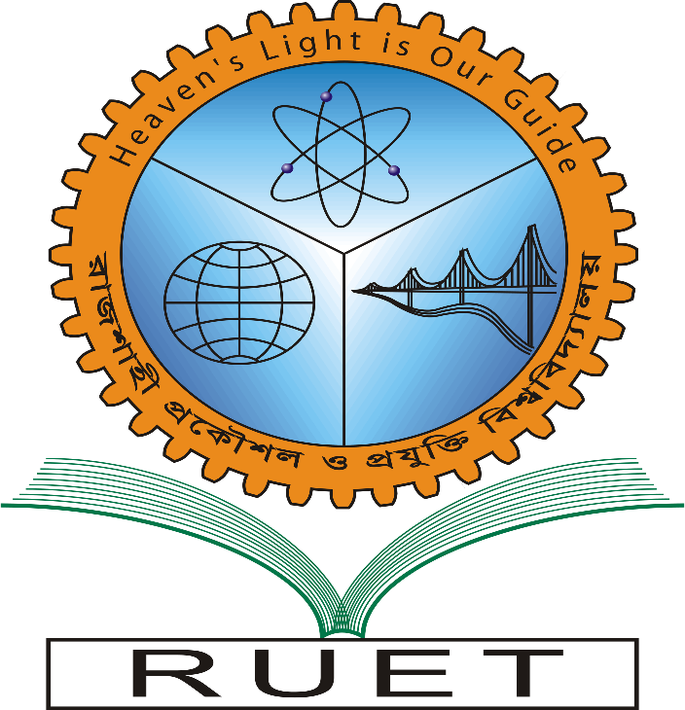**Rajshahi University of Engineering & Technology**

Department of Electrical & Computer Engineering

Course No: ECE 4124

Course Title: Digital Signal Processing Sessional

Experiment No: 02

Experiment Name: Correlation of Signals

|  |  |
| --- | --- |
| **Submitted by:**  Name: Md. Zayed Al Masud  Roll: 1810016  Date of Experiment: 03. 05. 2023  Date of Submission: 15. 05. 2023 | **Submitted to:**  Hafsa Binte Kibria  Lecturer,  Dept. of ECE |

**Theory:**

Correlation is a mathematical operation that is very similar to convolution. Just as with convolution, correlation uses two signals to produce a third signal. This third signal is called the **cross-correlation**of the two input signals. If a signal is correlated with *itself*, the resulting signal is instead called the **autocorrelation**. Correlation is an operation used in many applications in digital signal processing. It is a measure of the degree to which two sequences are similar

**Code:**

**Output:**

Fig 2.1: Auto Correlation

Fig 2.2: Cross Correlation

**Conclusion:**